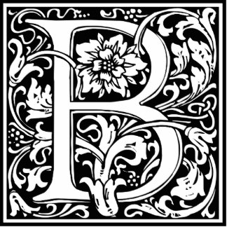
ehold!

Medieval

Europe

Step 1: Choose a topic from this list or negotiate your own;

- Politics
- Economics
- Religion
- Entertainment
- Crusades
- Medicine
- Crime and Punishment
- Daily Life
- Military
- Cities and Architecture

Step 2: Research Your Topic (from 590 C.E. to 1500 C.E.)
You must answer all questions. Write at least 50 words for each.

- Who are some important groups or individuals involved in your topic? How? Why? What is the feudal system and how does it relate to your topic or the people involved with your topic?
- If you were in a person within your topic in Medieval times e.g a doctor, priest, jester, etc,
  - Who would make up your social life? Would you be with royalty or the lowest classes? What would you do in your spare time? Sport, games, craft, theatre?
  - Tell us about your cultural life. What would you wear? Eat? What sort of housing would you live in?
  - How would you survive in your economy? What could you sell/buy and from whom?
  - Tell me about what you think of your government and political structures. What are the rules/laws in Medieval times? What happens if you break a law? How are people punished?
- What were/are significant developments or achievements within your topic? Keep them in order. How has your topic changed? How has it stayed the same? Link it to present day.
- List at least 5 historical terms or words you learned while researching. What does each mean?
- What sorts of research sources do you use? Provide a list. Why do you think each one was truthful/useful? What is a primary source? What is a secondary source? (You can find this on 8ail.weebly.com)
- One of your own questions.

http://www.medieval-life-and-times.info/medieval-art/

